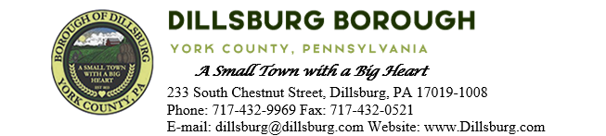
COUNCIL MEETING AGENDA
April 9, 2024 at 6:00pm

- Call to Order
- Invocation/Salute to the Flag
- Roll Call of Members
- Approval of the Agenda
- Approval of the Minutes
  - Committee Meeting: March 5, 2024
  - Council Meeting: March 12, 2024
- Public Comment- 5 Minutes per Valid Speaker
- Subdivision/Land Development
- Department Reports
  - Police
  - EMS
  - Fire Department
  - Planning Commission
  - Dillsburg Area Authority
  - Community Groups
    - New Hope Ministries
    - Logan Park
    - Dillsburg Senior Center
  - Solicitor
  - Engineer
  - Treasurer
  - Tax Collector
  - Borough Staff Report
- Mayor’s Report
- President’s Report
- Public Safety
- Public Works Committee
- Administrative Committee
- Old Business
  - Lobar Maintenance Agreement
  - Truck Parking Ordinance
- New Business
  - Camera Installation in Community Room
- Adjournment

