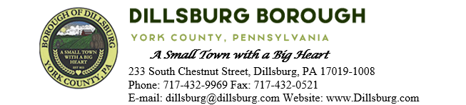
COUNCIL MEETING AGENDA
March 12, 2024 at 6:00pm

- Call to Order
- Invocation/Salute to the Flag
- Roll Call of Members
- Approval of the Agenda
- Approval of the Minutes
  - Committee Meeting: February 6, 2024
  - Council Meeting: February 13, 2024
- Public Comment- 5 Minutes per Valid Speaker
  - South Mountain Trolley Greenway
- Subdivision/Land Development
  - Verizon Wireless Land Development Plan and Waiver
- Department Reports
  - Police
  - EMS
  - Fire Department
  - Planning Commission
  - Dillsburg Area Authority
  - Community Groups
  - Solicitor
  - Engineer
  - Treasurer
  - Tax Collector
  - Borough Staff Report
- Mayor’s Report
- President’s Report
- Public Safety
- Public Works Committee
- Administrative Committee
  - Approve Tax Exemption Request
  - Resolution 2024-5 Northern York Comp Plan
- Old Business
  - Community Room Kitchen
  - Lobar Maintenance Agreement
  - Clock Restoration
- New Business
- Adjournment

