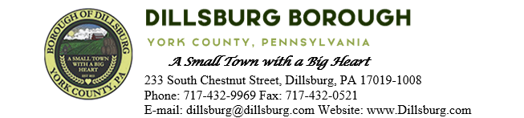
COUNCIL MEETING AGENDA
January 9th, 2024 at 6:00pm

- Call to Order
- Invocation/Salute to the Flag
- Roll Call of Members
- Approval of the Agenda
- Approval of the Minutes
  - Committee Meeting- December 5 2023
  - Council Meeting- December 12 2023
- Public Comment- 5 Minutes per Valid Speaker
- Department Reports
  - Police
  - EMS
  - Fire Department
  - Planning Commission
  - Dillsburg Area Authority
  - Community Groups
    - DCA (Pickle Drop)
  - Solicitor
  - Engineer
  - Treasurer
  - Tax Collector
  - Borough Staff Report
- Mayor’s Report
- President’s Report
- Public Safety
  - Approve Resolution 2024-3 Appointing EMA Coordinator Ethan Still
  - Approve Invoicing NEMA $400
- Public Works Committee
  - Purchase of Plow for Skid Loader
- Administrative Committee

- Old Business
  - Creek Restoration Project Update
- New Business
- Adjournment

