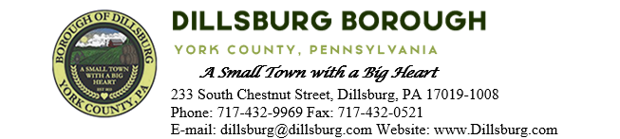
COUNCIL MEETING AGENDA
December 12, 2023

- Call to Order
- Invocation/Salute to the Flag
- Roll Call of Members
- Approval of the Agenda
- Approval of the Minutes
  - Committee Meeting- November 8 2023
  - Council Meeting- November 14 2023
- Public Comment- 5 Minutes per Valid Speaker
- Department Reports
  - Police
  - EMS
  - Fire Department
  - Planning Commission
  - Dillsburg Area Authority
  - Community Groups
  - Solicitor
  - Engineer
  - Treasurer
  - Tax Collector
  - Borough Staff Report
- Mayor’s Report
- President’s Report
- Public Safety
- Public Works Committee
- Administrative Committee
  - Resolution 2023-12 2024 Tax Millage
  - Resolution 2023-13 IRS Mileage Reimbursement Rate for 2024
  - Resolution 2023-14 2024 Fee Schedule
  - Resolution 2023-15 Appoint Logan Park and Dillsburg Area Authority seats
  - Approve Employee Handbook
  - Amend Adopted 2024 Budget

- Old Business
  - Emergency Flashing Sign for Fire Department
- New Business
- Adjournment

