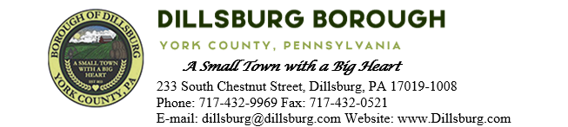
COUNCIL MEETING AGENDA
November 14, 2023

- Call to Order
- Invocation/Salute to the Flag
- Roll Call of Members
- Approval of the Agenda
- Approval of the Minutes
  - Committee Meeting- October 3 2023
  - Council Meeting- October 10 2023
- Public Comment- 5 Minutes per Valid Speaker
- Department Reports
  - Police
  - EMS
  - Fire Department
  - Planning Commission
  - Dillsburg Area Authority
  - Community Groups
  - Solicitor
  - Engineer
  - Treasurer
  - Tax Collector
  - Borough Staff Report
- Mayor’s Report
- President’s Report
- Public Safety
- Public Works Committee
  - Approve Rita’s Land Development Time Extension
  - Winfield Preliminary Plan
  - Approve payment for Quay Alley
  - Approve payment to JVI for Chestnut St Sidewalk Project
  - Approve Shop Exhaust Fan for Public Works Bay
- Administrative Committee
  - Approve Multi-municipal Comprehensive Plan RFP
  - Approve 2024 Meeting Dates
  - 2024 Appointments
  - Approve 2024 Borough Budget
- Old Business
  - Emergency Flashing Sign for Fire Department
- New Business
  - 1st Quarter 2024 Penn Waste Price Increase
  - Salt shed for Borough building
- Adjournment

