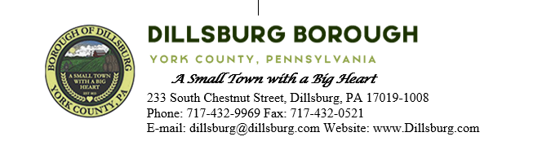
COUNCIL MEETING AGENDA
October 10, 2023

- Call to Order
- Invocation/Salute to the Flag
- Roll Call of Members
- Approval of the Agenda
- Approval of the Minutes
  - Committee Meeting- September 5 2023
  - Council Meeting- September 12 2023
- Public Comment- 5 Minutes per Valid Speaker
  - Zack Semke- Boyscout troop 38 eagle scout project
- Department Reports
  - Police b. EMS
  - Fire Departments c. Treasurer
  - Planning Commission d. Dillsburg Area Authority
  - Community Groups e. Solicitor
  - Engineer f. Tax Collector
  - Borough Staff Report
- Mayor’s Report
- President’s Report
- Public Safety
  - Approve 2024 Contract with SPCA
- Public Works Committee
- Administrative Committee
  - Approve advertisement of Proposed 2024 Budget
  - Approve 2024 MMO
- Old Business
  - Emergency Flashing Sign for Fire Department
- New Business
  - Approve the purchase of a power floor scrubber for community room
  - Approve Lobar quote for electrical outlets for EMS office
  - Approve purchase of acoustic panels for community room
  - Approve the participation in the multi-government Comprehensive Plan update

- Executive Session
- Adjournment

