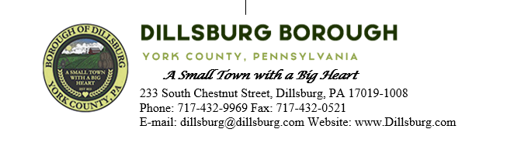
COUNCIL MEETING AGENDA
September 12, 2023
***Public Hearing***
Ordinance 2023-1 Appointing CAO

- Call to Order
- Invocation
- Salute to the Flag
- Roll Call of Members
- Approval of the Agenda
- Approval of the Minutes
  - Committee Meeting- August 2 2023
  - Council Meeting- August 8 2023
- Public Comment- 5 Minutes per Valid Speaker
- Department Reports
  - Police
  - EMS
  - Fire Departments
  - Treasurer
  - Planning Commission
  - Dillsburg Area Authority
  - Community Groups
  - Solicitor
  - Engineer
  - Tax Collector
  - Borough Staff Report
- Mayor’s Report
- President’s Report
- Public Safety
  - Set the date for Trick-or-Treat Night
  - Approve Purchase of Emergency Flashing Sign for Fire Department
- Public Works Committee
  - Approve 2023 Crosswalk Painting
  - Approve Winfield Preliminary Plan Time Extension
  - S Baltimore St sidewalk final invoice
- Administrative Committee
  - Amending Resolution to remove 2-hour minimum requirement off Fee Schedule
  - Approve opening investment account with PLGIT
- Old Business

- New Business
  - Resolution to approve LSA program application for Alley construction
  - Resolution to approve LSA program application for Generator
- Executive Session
- Adjournment

