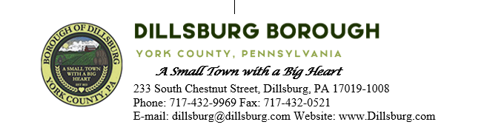
COUNCIL MEETING AGENDA
August 8th, 2023
- Call to Order
- Invocation
- Salute to the Flag
- Roll Call of Members
- Approval of the Agenda
- Approval of the Minutes
  - Committee Meeting- July 5 2023
  - Council Meeting- July 11 2023
- Public Comment- 5 Minutes per Valid Speaker
- Department Reports
  - Police
  - EMS
  - Fire Departments
  - Treasurer
  - Planning Commission
  - Dillsburg Area Authority
  - Community Groups
  - Solicitor
  - Engineer
  - Tax Collector
  - Borough Staff Report
- Mayor’s Report
- President’s Report
- Public Safety
- Public Works Committee
- Administrative Committee
  - Resolution 2023-7- Extending term of agreement for the York County Regional Chesapeake Bay Pollutant Reduction Plan
  - Approve Change Order for S Baltimore St Sidewalk Project
  - Approve rental of Skid Loader from Golden Rentals
  - Approve purchase of stone for alley project
- Old Business

- New Business

- Adjournment

