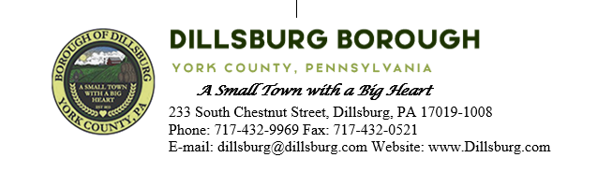
COUNCIL MEETING AGENDA
June 13th, 2023
- Call to Order
- Invocation
- Salute to the Flag
- Roll Call of Members
- Approval of the Agenda
- Approval of the Minutes
  - Committee Meeting- May 2 2023
  - Council Meeting- May 9 2023
- Public Comment- 5 Minutes per Valid Speaker
- Department Reports
  - Police
  - EMS
  - Fire Departments
  - Treasurer
  - Planning Commission
  - Dillsburg Area Authority
  - Community Groups
    - NEMA
  - Solicitor
  - Engineer
  - Tax Collector
  - Borough Staff Report
- Mayor’s Report
- President’s Report
- Public Safety
- Public Works Committee
  - Bids for Tree Removal by Pavilion
  - Bids for S Baltimore St
- Administrative Committee
- Old Business
- New Business
- Adjournment

